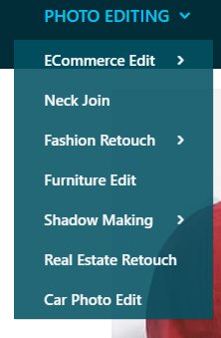
Html

<!DOCTYPE html>
<html lang="en">
<head>
<meta charset="UTF-8">
<title>Hover Dropdown</title>
<link rel="stylesheet" href="style.css">
</head>
<body>

<div class="menu">
<div class="menu-title">
PHOTO EDITING <span>▼</span>
</div>

<div class="submenu">
<div class="item">ECommerce Edit <span>›</span></div>
<div class="item">Neck Join</div>
<div class="item">Fashion Retouch <span>›</span></div>
<div class="item">Furniture Edit</div>
<div class="item">Shadow Making <span>›</span></div>
<div class="item">Real Estate Retouch</div>
<div class="item"><a href="https://www.google.com/">Car Photo Edit</a></div>
</div>
</div>

</body>
</html>

Css
body {
margin: 0;
font-family: Arial, sans-serif;
background: #f2f2f2;
}

/* Container */
.menu {
width: 260px;
margin: 50px;
position: relative; /* IMPORTANT */
}

/* Title */
.menu-title {
background: #0c7a86;
color: white;
padding: 12px 15px;
font-weight: bold;
cursor: pointer;
display: flex;
justify-content: space-between;
align-items: center;
}

/* Submenu (hidden) */
.submenu {
position: absolute;
top: 100%; /* directly under title */
left: 0;
width: 100%;
background: #2d6f78;

opacity: 0;
visibility: hidden;
transform: translateY(0); /* remove gap */

transition: opacity 0.3s ease, visibility 0.3s ease;
}

/* Show on hover */
.menu:hover .submenu {
opacity: 1;
visibility: visible;
}

/* Items */
.item {
padding: 12px 15px;
color: #e6f4f6;
border-bottom: 1px solid rgba(255,255,255,0.1);
display: flex;
justify-content: space-between;
align-items: center;
cursor: pointer;
transition: background 0.3s;
}

a {
text-decoration: none;
color: white;
}

.item:hover {
background: #1f5961;
}

/* Arrow */
.item span {
font-size: 18px;
}

